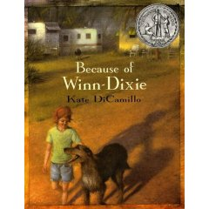

Multi-Text
Study

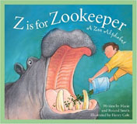

Created by:
Christa Groce

Spring 2006

Because of Winn-Dixie
Literary Packet Outline

Week One
Before Reading: Day 1 (Small Group)
  - Cover Page with poem: Roger The Dog by Ted Hughes
  - Anticipation Guide
  - Concept Map (Pets)
  - Predictions of Story Elements
Pg. 1-25 Day 2 (Individual)
  - Vocabulary Activity (Introduce and Begin)
  - Friendly Letter & Artistic Representation (From Opal to her Mom)
Pg. 26-51 Day 3 (Individual/Whole Group/Individual)
- Vocabulary Activity (individual)
- ABC Book Assignment (whole)
- Character Sketcher (Opal) (individual)
Pg. 52-66 Day 4 (Small Group)
- Vocabulary Activity
- Discussion Director
Pg. 67-78 Day 5 (Paired Reading & Activities)
- Vocabulary Activity
- Internet Workshop (Thunderstorms)
Week Two
Pg. 79-91 Day 6 (Individual/Whole Group/Individual)
- Vocabulary Activity (individual)
- Complete Internet Workshop
- Read: Z is for Zookeeper by Marie and Roland Smith (whole)
- I-Poem & Trading Card Activity (individual)
Pg. 92-117 Day 7 (Individual)
- Vocabulary Activity
- Character Sketcher: Characterization (Amanda Wilkinson)
Pg. 118-127 Day 8 (Individual)
- Vocabulary Activity
- Double Entry Diary

Pg. 128-149 Day 9 (Individual)
- Vocabulary Activity
- Learning Log/Response Journal
Pg. 150-168 Day 10 (Pairs)
- Vocabulary Activity
- Reward Poster for Winn-Dixie
Week Three
Pg. 169-182 Day 11 (Individual)
- Vocabulary Activity
- A Poem for Two Voices (Winn-Dixie and Opal)
After Reading: Day 12 (Whole Group)
- Revisit Story Elements Predictions
- Complete Anticipation Guide
- ABC Book to be completed and turned in.
- Author’s Craft
- Final Vocabulary Assessment
Because of Winn-Dixie
By Kate DiCamillo
~
Z is for Zookeeper
By Marie and Roland Smith
Roger the Dog
by Ted Hughes

Asleep he wheezes at his ease.
He only wakes to scratch his fleas.

He hogs the fire, he bakes his head
As if it were a loaf of bread.

He’s just a sack of snoring dog,
You can lug him like a log.

You can roll him with your foot.
He’ll stay snoring where he’s put.

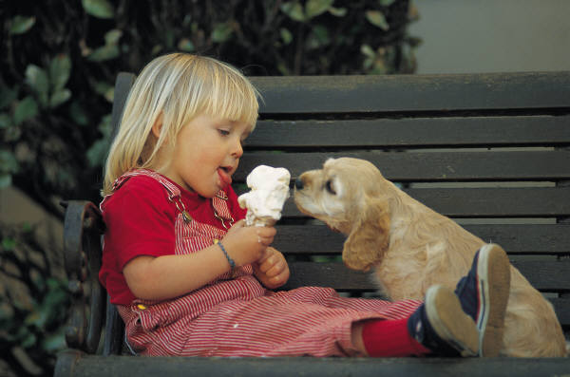
Take him our for exercise
He’ll roll in cowclap up to his eyes.

He will not race, he will not romp.
He saves his strength for gobble and chomp.

He’ll work as hard as you could wish
Emptying the dinner dish,

Then flops flat, and digs down deep,
Like a miner into sleep.

Name____________________________________________
(Day 1)

Anticipation Guide
Before Reading Because of Winn-Dixie:
Read each statement and mark, in the "Me" column a positive (+) or a negative (-). A positive being that you agree with the statement and a negative being you disagree with the statement. Be sure to mark each statement with a positive or a negative.

During the Reading of the Story:
Think about how the author feels about each of the statements.

After Reading:
After you have read the story, fill in the "Author" column.

M=my opinion A=Author's point of view
M____A____ 1. A dog is a man’s best friend.
M____A____ 2. Family is most important in life.
M____A____ 3. Always judge a book by its cover.
M____A____ 4. If a person is hateful to you it is always because they do not like you.
M____A____ 5. Learn to be happy with the things you have.
(Day 1)
Concept Map: Because of Winn-Dixie

Pets

(Day 1)
Predictions of Story Elements
Before you read: Look carefully at the front and back covers of Because of Winn-Dixie. Write down your predictions about the following:

Setting (Time and Place): When and where do you think book takes place? _______________________________________________

________________________________________________________________________
Characters (The people, animals, or objects around which the action of the story is centered): Who do you believe the main characters in the book will be? _________________________________________

________________________________________________
 Problem(s) & Solution(s) (What goes wrong in the story and how is it solved?) What do you predict will be the most significant problems in the book? How do you believe the problems may be solved? ____________

________________________________________________________________________

________________________________________________________________________

Write down any other questions or predictions: _________________________

(Day 1)
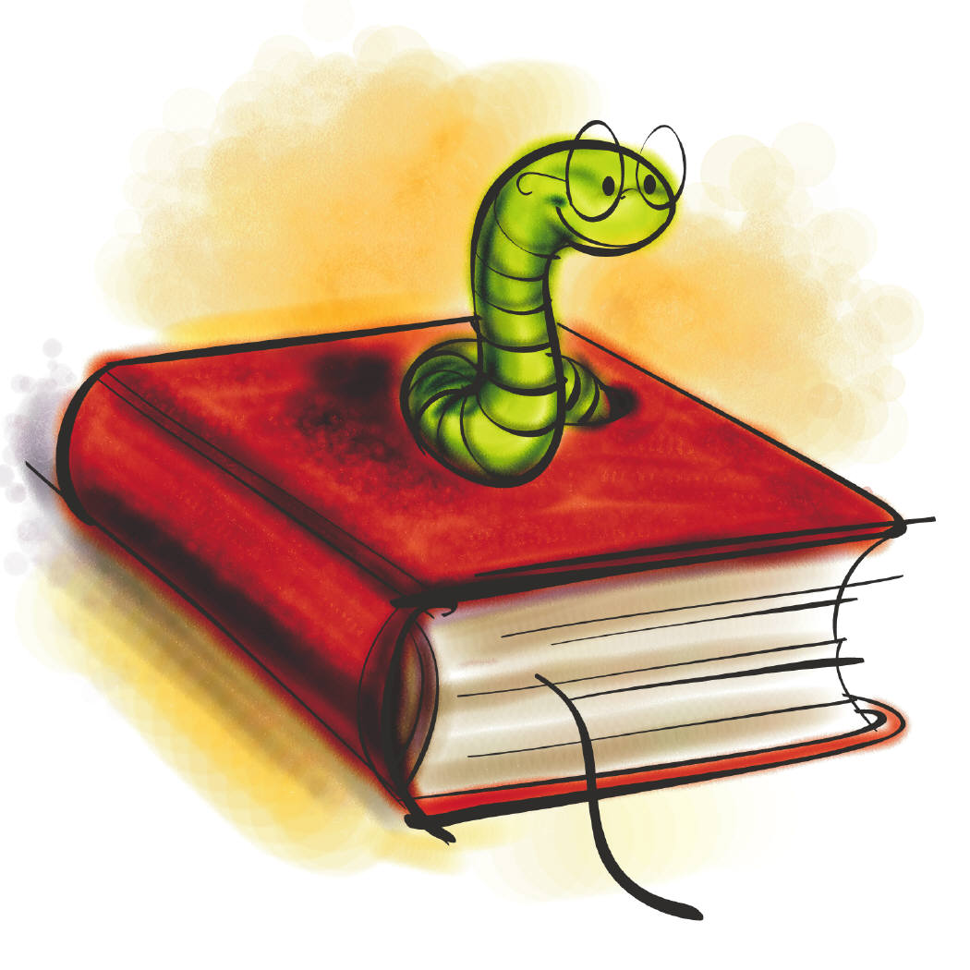
Vocabulary (Day 2)
Because of Winn-Dixie
You will complete the following chart with child-friendly definitions for these words. Then, you are invited to complete a set of daily vocabulary activities to go with these words.

Word | Meaning
concerned
p. 9

missionary
p. 13

distracted
p. 14
exception
p. 15
stray
p. 18

(Day 2)
Vocabulary Activities (Day 2)
Because of Winn-Dixie

Word Networks
- What people, things, situations, or words come to mind when you think about the word missionary?

missionary

Synonyms and Antonyms
Synonym | Word | Antonym
 | concerned
 | distracted
 | stray

Sentence Stems/Idea Completions
Winn-Dixie was the exception because he (p. 15)__________________________
__________________________________________________________________________.
(Day 2)

Friendly Letter
Because of Winn-Dixie

You are invited to write a letter from Opal Buloni’s point of view to her Mother. Be true to the character, setting, and story, and be sure to include the necessary parts of a friendly letter. Brainstorm your ideas here and then begin your letter on a separate piece of paper. Remember to write neatly and take your time! Here are a few questions for you to consider before you begin:

- What do you think Opal wants to tell her mom ?

- What has changed since Opal last saw her mother?

- What questions does Opal have for her mom?

- Think about a picture Opal might draw to send along with the letter. What would it be?

**Be sure to include an artistic drawing to go along with Opal’s letter!**

(Day 2)
Vocabulary (Day 3)
Because of Winn-Dixie
You will complete the following chart with child-friendly definitions for these words. Then, you are invited to complete a set of daily vocabulary activities to go with these words.

Word | Meaning
recognize
p.30
trembling
p. 42
prideful
p. 45
peculiar
p. 47
friendless
p. 50

(Day 3)
Vocabulary Activities (Day 3)
Because of Winn-Dixie

Word Networks
- What people, things, situations, or words come to mind when you think about the word peculiar?

peculiar

Synonyms and Antonyms
Synonym | Word | Antonym
 | trembling
 | prideful
 | recognize

Sentence Stems/Idea Completions
A person who is friendless________________________________________________
__________________________________________________________________________.
(Day 3)
 Book Assignment
Because of Winn-Dixie
Choose 1 or 2 items from the chart below to create pages for an alphabet book for all to share. Each page should include a large capital letter, an illustration or some artistic impression, and a paragraph (at least 5 sentences) explaining your letter representation. Design your page with an interesting format and type font. Your page should be vertical. The following are examples you may use but are not limited to:

A  Amanda Wilkinson |  | B  bear |  | C  church,  criminal,  Civil War |  | D  Dunlap Dewberry,  daddy | E  expensive  (p. 53)
F  Florida,  Franny Block,  friends |  | G  Gertrude’s-Pets,  guitar,  Gloria Dump |  | H  Herman W. Block Memorial Library |  | I  installment plan  (p. 53),  invitation (p. 59),  identical brothers | J  jail
K  kiss  (p. 125) |  | L  library,  Littimus W. Block |  | M  missionary,  music,  melancholy |  | N  Naomi, FL. | O  Opal, Otis
P  Preacher,  parrot,  party | Q  Pick-It-Quick  (p. 32) |  | R  rain |  | S  Stevie Dewberry,  Sweetie Pie Thomas |  | T  thunder storm, turtle
U  umbrella  (p. 157) | V  love  (p. 167) |  | W  Winn-Dixie,  war  X  ? |  | Y  lonely (p. 133)  Z lozenges
(Day 3)
Character Sketcher Activity
Because of Winn-Dixie

OPAL BULONI

Your job as Character Sketcher is to identify the character’s actions (traits) and explain or prove these traits, identify the character’s goal (which is what the character wants to do or accomplish), identify the problem and solution in the reading, and complete a sketch or illustration of the character.
You need to be aware that the character traits you will choose will be implied character traits. In other words, they are not directly stated in the passage. You really want to use descriptive words for your character traits. You do not want to use words like good, bad, nice, and mean. Be sure to use your “Descriptive Character Traits” page for help.
Sometimes the solution to your character’s problem will not be in the section of the book that you are reading. In this case, you will need to come up with a possible solution for your character’s problem. When you begin artistically representing your character, try to use any physical descriptions from the text to help you. Your “artistic impression” of the character will probably be on a separate piece of paper. The next page gives you an example of how your paper may look with the character information.

(Day 3)
Character’s Name: OPAL BULONI
Section and title of the book you are reading: __________________________________

Implied Character Traits
1. (trait)________________ p. __ par. ___
Explanation or proof of trait:

2. (trait)________________p. __par.____
Explanation or proof of trait:

3. (trait)________________p. ___par.____
Explanation or proof of trait:

Character Goal: _____________’s goal is to __________________________

________________________________________________________________.

Problem: ____________’s problem is________________________________

________________________________________________________________.
Solution or Possible Solution:______________________________________

________________________________________________________________.

(Day 3)
Vocabulary (Day 4)
Because of Winn-Dixie
You will complete the following chart with child-friendly definitions for these words. Then, you are invited to complete a set of daily vocabulary activities to go with these words.

Word | Meaning
furious
p. 53
expensive
p. 53
allowance
p. 53
trustworthy
p. 55
identical
p. 61

(Day 4)
Vocabulary Activities (Day 3)
Because of Winn-Dixie

Word Networks
- What people, things, situations, or words come to mind when you think about the word identical?

identical

Synonyms and Antonyms
Synonym | Word | Antonym
 | furious
 | expensive
 | trustworthy

Sentence Stems/Idea Completions
A person might get an allowance if _______________________________________
__________________________________________________________________________.

(Day 4)
Discussion Director
Because of Winn-Dixie



- Your job is to involve the students in your group by thinking and talking about the section of the book you have just read. You are going to ask questions that really help the students in your group think about the reading. Your questions should require students to discuss their interpretations of the text and connect background experience and knowledge with the text. You want all students involved in the discussion and talking about issues that come up during the reading.

- Your job as the Discussion Director is to come up with 5 thinking questions. Your teacher really wants you to help the students in your group to go back to the book to find their answers if they don’t know them. So, to help this run very smoothly, you need to write down the questions, your answers to your questions, and the page numbers where the students can reference the text to justify their responses to your questions.

Use the record chart on the next page to help your organize your thoughts and questions.

(Day 4)
Discussion Director Record Chart
Because of Winn-Dixie
** Must do at least 5 .**

Question: | Answer: | Page #:
1.
2.

3.

4.

5.

6.

7.

8.

(Day 4)
Vocabulary (Day 5)
Because of Winn-Dixie
You will complete the following chart with child-friendly definitions for these words. Then, you are invited to complete a set of daily vocabulary activities to go with these words.

Word | Meaning
amazed
p. 67
whimpering
p.72
barreling
p. 74

pathological
p. 75
terrorized
p. 76

(Day 5)
Vocabulary Activities (Day 5)
Because of Winn-Dixie

Word Networks
- What people, things, situations, or words come to mind when you think about the word terrorized?

terrorized

Synonyms and Antonyms
Synonym | Word | Antonym
 | whimpering
 | amazed
 | barreling

Sentence Stems/Idea Completions
A person may have a pathological fear of thunderstorms if they____________
__________________________________________________________________________.

(Day 5)
Internet Workshop
Because of Winn-Dixie
This internet workshop will help you to better understand thunderstorms and lightning. Please do the following steps to complete this internet activity:
1. | Read the question below and then explore the websites given.
2. | Then answer the questions about the websites that are listed below on notebook paper.
3. | Make a poster containing the information you found out concerning thunderstorms/lightning. Be sure to be creative and neat! It’s your job to pick out the most important info and put it on your poster.
4. | Get familiar with your poster because you are going to share it will the class! ☺

- Read about how Thunderstorms are formed by just clicking on the blue words or by following the link below:
(http://eo.ucar.edu/webweather/thunder2.html)
Then answer the following questions:
- How many types of thunderstorms are there? Name and describe them. (How are they different?) ______________________________________________________________________________________________________________________________________________________________________________________________________
- What happens to air during a thunderstorm? Describe it’s temperature and motion. ______________________________________________________________________________________________________________________________________________________________________________________________________
- What are the two main ingredients of a thunderstorm? __________________________________________________________________
*Before you leave this site be sure to scroll down and check out the link: LIGHTNING IMPACTS OUR LIVES at the bottom of the site! It’s neat and informs you about lightning safety and how to figure out how far a storm is from where you are.
  - Then visit: http://eo.ucar.edu/webweather/thunderhome.html . Scroll down to the picture labeled lightning and click on: HOW IN THE WORLD IS LIGHTNING FORMED. Then draw a diagram in the box below that illustrates how lightning is formed. Be sure to include a description of your drawing.

  - Finally, visit: http://yahooligans.yahoo.com/content/ask_earl/20010102.html and figure out why thunder makes such a big boom. Write the answer below: ________________________________________________________________________________________________________________________________________________________________________________________________________________________
  - How do these websites relate to the book Because of Winn-Dixie? __________________________________________________________________________________________________________________________________________________________________________________________________________________________________________________________________Now make your poster with all the new information you have just learned about storms and lightning!! Have FUN and ENJOY!
Vocabulary (Day 6)
Because of Winn-Dixie
You will complete the following chart with child-friendly definitions for these words. Then, you are invited to complete a set of daily vocabulary activities to go with these words.

Word | Meaning
criminal
p. 84
charming
p. 85
routine
p. 87
retarded
p. 90
Ignorant
p.91

(Day 5)
Vocabulary Activities (Day 5)
Because of Winn-Dixie

Word Networks
- What people, things, situations, or words come to mind when you think about the word criminal?

criminal

Synonyms and Antonyms
Synonym | Word | Antonym
 | routine
 | retarded
 | charming

Sentence Stems/Idea Completions
Why does Opal think the others are ignorant? (p. 91) _____________________
__________________________________________________________________________.

(Day 6)
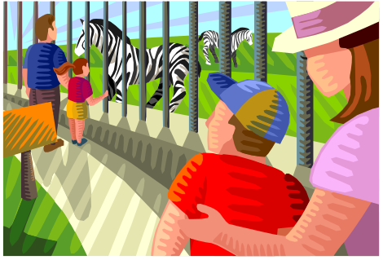
Z is for Zookeeper
By Marie and Roland Smith

You are invited to read the book, Z is for Zookeeper. This book provides you with loads of useful information about zoo animals and the hard task of animal up-keep. When you are finished reading, your job is to choose ONE of the following activities to complete:

- Write an I-poem from the point of view of one of the zoo workers or animals.

OR

- Create a Trading Card for one of the zoo workers or animals.

Please circle the activity you would like to create and then flip to the appropriate one in the packet to begin.

Have fun!
☺

(Day 6)

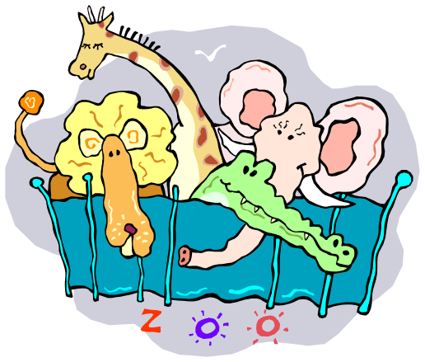
I-Poem Activity
On a separate sheet of white paper, neatly write an I-Poem from the point of view of one of the animals or workers in Z is for Zookeeper. Try to get inside your animal or worker’s head; help the reader identify with that animal or workers thoughts, actions, and personality. If possible, include a simile in your poem. Either use the format below or think of your own—just be creative. Be sure to include a colorful drawing of your worker or animal before you finish.
I am ________________________.
(An adjective to describe his/her personality).

I look _______________________.
(A physical description, maybe you could use a simile here).

I like to _____________________.
(Describe what the person likes to do or his/her job during the day.)

I use to live (in or at) the ________________________ but now I spend most of my time at the zoo.

I miss my _____________________.
(What does this animal/worker miss?)

I may be called ______________________.
(Another adjective).

I believe I am ________________________.
(One more adjective)

I am _____________________________.
(The animal’s or worker’s name.)
Question to think about:
How does the zookeeper’s job in Z is for Zookeeper compare or relate to Otis’ and Opal’s jobs at Gertrude’s Pets in Because of Winn-Dixie?

Trading Card Activity

Your job is to create, (on a separate sheet of white paper), a trading card for one of the animals or workers in the book, Z is for Zookeeper. Be creative and think of your own design. Be sure to include all of the following information and a colorful image of your worker or animal on the card:

ZOO ANIMAL TRADING CARD MUST INCLUDE:
- Name of animal_______________________________.
- Hobby________________________________________.
- Original Home/Habitat________________________.
- Favorite Food ________________________________.
- Favorite part about living in a zoo_____________.
- Least favorite part about living in a zoo________.

ZOO WORKER TRADING CARD MUST INCLUDE:
- Job Title______________________________________.
- Animals they work with_______________________.
- Favorite part about the job____________________.
- Least favorite part about the job_______________.
- Why I became a zoo worker____________________.
- My favorite zoo animal and why________________.

Some of these things can be found in the book and some information will take additional research and imagination! Remember to be creative and take your time! Enjoy! ☺

Question to think about:
How does the zookeeper’s job in Z is for Zookeeper compare or relate to Otis’ and Opal’s jobs at Gertrude’s Pets in Because of Winn-Dixie?
Vocabulary (Day 7)
Because of Winn-Dixie
You will complete the following chart with child-friendly definitions for these words. Then, you are invited to complete a set of daily vocabulary activities to go with these words.

Word | Meaning
imitated
p. 92
suggestion
p.100-101
occurred
p.104
enlisted
p. 1054
manufactured
p. 111

(Day 7)
Vocabulary Activities (Day 7)
Because of Winn-Dixie

Word Networks
- What people, things, situations, or words come to mind when you think about the word manufacture?

manufacture

Sentence Stems/Idea Completions
What does it mean to enlist in the army? __________________________________
__________________________________________________________________________.
Susie occurred to have_____________________________________________________.
My teacher made the suggestion to ________________________________________
___________________________________________________________________________.
Opal imitated her friends when she__________________________________________
____________________________________________________________________________.

(Day 7)
Character Sketcher Activity
Because of Winn-Dixie

AMANDA WILKINSON

Your job as Character Sketcher is to identify the character’s actions (traits) and explain or prove these traits, identify the character’s goal (which is what the character wants to do or accomplish), identify the problem and solution in the reading, and complete a sketch or illustration of the character.
You need to be aware that the character traits you will choose will be implied character traits. In other words, they are not directly stated in the passage. You really want to use descriptive words for your character traits. You do not want to use words like good, bad, nice, and mean. Be sure to use your “Descriptive Character Traits” page for help.
Sometimes the solution to your character’s problem will not be in the section of the book that you are reading. In this case, you will need to come up with a possible solution for your character’s problem. When you begin artistically representing your character, try to use any physical descriptions from the text to help you. Your “artistic impression” of the character will probably be on a separate piece of paper. The next page gives you an example of how your paper may look with the character information.

(Day 7)
Character’s Name: AMANDA WILKINSON

Section and title of the book you are reading: __________________________________

Implied Character Traits
1. (trait)________________ p. __ par. ___
Explanation or proof of trait:

2. (trait)________________p. __par.____
Explanation or proof of trait:

3. (trait)________________p. ___par.____
Explanation or proof of trait:

Character Goal: _____________’s goal is to __________________________

________________________________________________________________.

Problem: ____________’s problem is________________________________

________________________________________________________________.
Solution or Possible Solution:______________________________________

________________________________________________________________.

(Day 7)
Vocabulary (Day 8)
Because of Winn-Dixie
You will complete the following chart with child-friendly definitions for these words. Then, you are invited to complete a set of daily vocabulary activities to go with these words.

Word | Meaning
sorrow
p. 119
invented
p. 120
peculiar
p. 121
melancholy
p. 121
apologize
p. 123

(Day 8)
Vocabulary Activities (Day 8)
Because of Winn-Dixie

Word Networks
- What people, things, situations, or words come to mind when you think about the word melancholy?

melancholy

Synonyms and Antonyms
Synonym | Word | Antonym
 | peculiar
 | sorrow

Sentence Stems/Idea Completions
I apologized after I _________________________________________________________.
Littmus W. Block invented_________________ and it tasted_____________________.

(Day 8)

Double-Entry Diary
Because of Winn-Dixie

You are invited to complete a Double-Entry Diary for this section of the book. Remember to write down the quotation or passage and the page number on the left side of your paper. On the right side of your paper, write your response or personal reactions and connections to what was written in the left column.

Quotation/Passage from the book. | Page | Your response, reactions, and connections to the quotation or passage.

(Day 8)
Vocabulary (Day 9)
Because of Winn-Dixie
You will complete the following chart with child-friendly definitions for these words. Then, you are invited to complete a set of daily vocabulary activities to go with these words.

Word | Meaning
theme
p. 141
arranging
p. 142
convinced
p. 143
swayed
p. 145
screeched
p. 148

(Day 9)
Vocabulary Activities (Day 9)
Because of Winn-Dixie

Word Networks
- What people, things, situations, or words come to mind when you think about the word screech?

screech

Sentence Stems/Idea Completions
The theme of the party was _________________________________________________.
After I finished arranging the desk it looked _________________________________.
I was convinced that _______________________________________________________
____________________________________________________________________________.
A person may sway during ________________________________________________.

(Day 9)
Response Journal
Because of Winn-Dixie


At the beginning of the story Opal could not stand Amanda Wilkinson. She often called her pinch-faced and mean, but in Chapter 21, Opal says she is happy to see Amanda at the party. What happened that changed the way Opal felt about Amanda? Do you remember a time when your feelings changed after you took the time to truly get to know someone? Explain on the lines below.

________________________________________________________________________________________________________________________________________________________________________________________________________________________________________________________________________________________________________________________________________________________________________________________________________________________________________________________________________________________________________________________________________________________________________________________________________________________________________________________________________________________________________________________________________________
(Day 9)
Vocabulary (Day 10)
Because of Winn-Dixie
You will complete the following chart with child-friendly definitions for these words. Then, you are invited to complete a set of daily vocabulary activities to go with these words.

Word | Meaning
amuse
p. 151
complicated
p. 153
appreciate
p. 153
downpour
p. 156
memorized
p. 163

(Day 10)
Vocabulary Activities (Day 10)
Because of Winn-Dixie

Word Networks
- What people, things, situations, or words come to mind when you think about the word melancholy?

downpour

Synonyms and Antonyms
Synonym | Word | Antonym
 | amuse
 | memorize

Sentence Stems/Idea Completions
My homework was complicated because_____________________________________
___________________________________________________________________________.
I could show my appreciation for something by______________________________
___________________________________________________________________________.

(Day 10)
Reward Poster for Winn-Dixie
Because of Winn-Dixie

Your job is to design a reward poster in order to help Opal Buloni find Winn-Dixie. You may have to go back to Chapters 1 and 2 to help with your drawing and descriptions. Be sure you include a description (physical and personality), name, reward amount, artistic drawing, and contact information for Opal Buloni. Also include why Winn-Dixie is so important and the reason she should be returned to Opal. Your poster should be neat and colorful! Be creative and have some fun when designing.

Materials you may use:
- Poster Paper
- Construction Paper
- Markers
- Colored Pencils
- Tissue Paper
- Crayons
- Glue stick
- Scissors
- Collage materials

Vocabulary (Day 11)
Because of Winn-Dixie
You will complete the following chart with child-friendly definitions for these words. Then, you are invited to complete a set of daily vocabulary activities to go with these words.

Word | Meaning
myth
p. 172
creeping
p. 174
mistake
p.177
teasing
p. 179
strum
p. 182

(Day 11)
Vocabulary Activities (Day 11)
Because of Winn-Dixie

Word Networks
- What people, things, situations, or words come to mind when you think about the word melancholy?

myth

Synonyms
Synonym | Word
 | creep
 | tease

Sentence Stems/Idea Completions
I made a mistake the other day when I ________________________________________
_____________________________________________________________________________.
Otis strummed his guitar by _________________________________________________
_____________________________________________________________________________.

(Day 11)
A Poem for Two Voices
Because of Winn-Dixie

Create a poem that focuses on India Opal and Winn-Dixie’s (physical) characteristics, personalities, and thoughts from the book. Think of some things that the Opal and Winn-Dixie might have the same and different views about. Then, get them to talk to one another. The lines are to be written across from one another and even though most poems rhyme this one DOES NOT have to. In addition, you are invited to include an artistic representation that symbolizes the theme of your poem. If you need some ideas just come find me and we will come up with something. Below is a format that you may way to practice on first. Enjoy and be creative! ☺
India Opal Winn-Dixie

______________________________
______________________________
______________________________
______________________________
______________________________
______________________________
______________________________
______________________________
______________________________
______________________________
______________________________
______________________________
______________________________
______________________________
______________________________

(Day 11)

Author’s Craft
Because of Winn-Dixie
Kate DiCamillo chooses her words very carefully, making use of several interesting literary devices. She appeals to the reader’s senses and sense of humor by using such figurative language. Find three examples of similes from the book, Because of Winn-Dixie and record them on the chart below. Then explain how each passage adds meaning to the story.
 | Page number/  Example/  What does this passage add to the story? | Page number/  Example/  What does this passage add to the story? | Page number/  Example/  What does this passage add to the story?
simile: a comparison that includes the words like or as  All the kids watched the woman as she moved along the line, her high-heeled shoes sounding like little fire-crackers going off on the wooden floor. | Pg:  Example:  What it adds to story: | Pg:  Example:  What it adds to story: | Pg:  Example:  What it adds to story:
(Day 12)
Final Vocabulary Assessment
Because of Winn-Dixie

Underline the best response or responses:

1. The best example of a stray animal is:
- A dog that has lives in the house.
- A pet fish.
- A street cat that appears to be lost.

2. A concerned person you would:
- Call to check on a friend who has been hurt.
- Laugh at someone when they fell down.
- Go and each pizza with their buddies.

3. A peculiar smell might:
- Smell good.
- Smell bad.
- Smell odd or strange.

4. A trustworthy person would:
- Steel money from a friend.
- Cheat on a test.
- Return lost money to the rightful owner.

5. If you heard a whimpering dog it would most likely be:
- Happy to see you.
- Hurt, scared, and in need of some help.
- Barking at the neighbor’s dog.

6. Where would you most likely see a criminal:
- On the streets.
- In jail.
- At a party.

7. If I described someone as being melancholy:
- They would be very happy.
- They would be very sad.
- They would be excited about something.

8. Which describes a screeching door:
- A door that does not make a sound when you open it.
- A door that slams shut.
- A door that makes a funny noise as you move it.

9. Something is complicated when:
- It is hard to understand.
- It is easy to understand.
- When you don’t even have to think about the answer, it just pops into your head.

10. I would most likely appreciate:
- A list of chores to do after school.
- The homework my teacher gave me.
- A surprise party my mom had planned for me.

11. I would mostly strum which instrument:
- The piano.
- The trumpet.
- The guitar.

12. If I were to say it had came a downpour this afternoon, it would mean:
- It had been sunny and nice.
- It had been very windy.
- It had rained a lot.

Rubric:
Because of Winn-Dixie

Activity/Criteria | Your points/Total possible points
Anticipation Guide  - Is completed in a thoughtful and considerate manner.  - Both sides are complete with positives/negatives. | /5
Concept Map  - Concept Map is neat and organized.  - Is thoughtful and shows considerations for Pets. | /5
Predictions of Story Element Activity  - All parts are considered.  - Predictions are carefully thought out and demonstrate consideration for the story. | /5
Vocabulary Activities 1,2,3,4,5,6,7,8,9,10, and 11  - Definitions are “child-friendly”  - Activities are correct and complete | /60  (5pts each)
Friendly Letter & Artistic Representation  - Provides information about book, insider information, and information about the characters' communities  - Is correct in format, appropriate in tone, and makes use of correct spelling, grammar, mechanics, and usage  - Includes artistic impression of character  - Includes all appropriate parts of friendly letter | /5
Page for Alphabet Book  - Information is correct and interesting  - Information is organized  - Design is creative and inviting | /5
Character Sketcher 1 (Opal) and 2 (Amanda)  - Sketch includes thoughtfully selected information about the character, including 3 implied character traits, problem and solution, and character goal  - Artistic Impression is creative and demonstrates knowledge of information given in text regarding character’s physical description | /10  * 5 pts each
Discussion Director  - Questions displays insights into novel’s main events and themes; questions are “higher-level”  - Answers are provided and when appropriate, page #’s | /5
Internet Workshop (1 workshop complete)  - Information in poster is correct and well organized; main ideas are present.  - Visual representation is present. | /5
Z is for Zoo Keeper Activity  - Trading Cards/I-Poems are completed in a considerate and organized manner.  - Artistic Drawing/Image is included  - Neatness and organization are present. | /5
Double-Entry Diary  - Example is well chosen, well explained and thoughtfully crafted  - Provides more than one thoughtful idea/supporting reason | /5
Response Journal  - Provides thoughtful idea and supports it with their writing. | /5
Reward Poster  - Includes description (physical and personality), name, reward amount, artistic drawing, and contact information.  - Also includes why Winn-Dixie is so important and the reason she should be returned to Opal. | /5
Poem for Two Voices  - Poem reveals insight into characters selected  - Poem includes dialogue that is true to the characters  - Artistic representation is creative and thoughtful | /5
Author’s Craft  - Chart includes 2 well-chosen examples of simile and onomatopoeia from the novel  - Explanations are included of how figurative language adds meaning to the text  - Artistic representation is thoughtful and creative | /5
Total | /135

Why did I choose…
Because of Winn-Dixie & Z is for Zoo Keeper:
I chose Kate DiCamillo’s fictional novel Because of Winn-Dixie, because I felt that fourth graders could really relate to the main character, Opal Buloni. This little girl loves animals, has friendship struggles, and at times questions life—which are all things that fourth graders deal with. Some students live in single home families, such as Opal, and need to be able to see that they are not the only one going through the same feeling of sadness and blame. Another reason I chose this book is because it deals with a lot of topics that I feel fourth graders are interested in such as: weather, animals, pets, parties, music, and friendships. I love this book because it is one that can speak to your heart and one that I feel children can connect with in their own lives.
I chose Z is for Zookeeper by Marie and Roland Smith to accompany this text because it was a way for students to see connections between animals in Gertrude’s Pet Store from the story, and the zoo. I wanted students to see the real aspects of having pets and being able to care for them; I wanted students to realize that animals need things just as humans do and demand a lot more than you expect at first. (A lot of times younger students want a pet but they do not realize how much care animals require). Another reason I chose this non-fictional text was because it is written on a higher and lower reading level all at the same time. This book is an ABC book that covers a wide range of animals and zoo keeper’s tasks. The lower level reader can read the text located on the picture and the higher level reader can read the text outside the picture. I love these books because they can reach both levels at once. Also, the fourth grade science curriculum addresses animal habitats. This unit could launch the study of animal behavior and adaptation.
The internet workshop I have prepared with these texts is one focusing on weather, mainly on thunderstorms. I believe children at this age are concerned about weather and this internet workshop is designed to foster that concern and interest. It shows you how thunderstorms are developed, how come lighting is so loud, and some safety tips to follow when there are storms in their area. This will prepare them for the further study of weather in fifth grade.
Both of these books are written on fourth grade reading levels and overall I believe this multi-text unit to be one that fourth-grade students will truly remember and carry with them through their lives. It contains realistic situations that these children can easily connect with and see relationships with in their own day to day lives. Hopefully by the end of this unit students will be able to understand that some things are hard in life but there are people that can help you through it, you do not have to be a lone. Opal’s wish for her mother to come back is a strong one, but by the end of the book she comes to terms with her mother’s absence and begins to focus on what she does have: her father and her friends.

References:
Dicamillo, Kate. Because of Winn-Dixie. Candlewick Press, Massachusetts. 2000. (4th grade reading level.)

Smith, Marie and Roland. Z is for Zookeeper. Sleeping Bear Press, MI. 2005. (3rd-4th grade reading level.)

URL Addresses:
- http://yahooligans.yahoo.com/content/ask_earl/20010102.html
- http://eo.ucar.edu/webweather/thunderhome.html
- http://eo.ucar.edu/webweather/thunder2.html

Additional books to go along with the unit:

Non-Fiction Books:
Branley, Franklyn. Hale, James. Down Comes the Rain. New York: Harper Collins Publishers, 1997.
- This book is about the rain cycle and explains why it rains and how the rain is formed. This book can be used to explain why it rains and the big downpour that takes place at the end of the story (Because of Winn-Dixie).

Michaels, Pat. Rose, Melanie. W is for Wind: A Weather Alphabet. Michigan: Sleeping Bear Press, 2005.
- This book may also be used in the section of Because of Winn-Dixie when it talks about Winn-Dixie’s pathological fear of thunderstorms and lightning. It is great to use when explaining the weather.

Hatkoff, Craig, Hatkoff, Isabella, & Kahumbu, Paula. Greste, Peter. Owen & Mzee: The true Story of a Remarkable Friendship. New York: Scholastic, 2005.
- This book would be good to use with this novel for several reason. One because is because of the comparison Opal makes between a turtle and her father. Two because it is about animals. Three, because is about friendships. All of these are topics that are mentioned in Because of Winn-Dixie.

Parker, Steve. Planet Animal. New York: Back Pack Books, 2000.
- This book would be good to use during the chapter that discusses all of the animals at Gertrude’s Pet Store. It is a great book and discusses the many different animals and their natural habitats.

Poetry
Dr. Seuss. Oh, the Places You’ll Go! New York: Random House, 1990.
- This book would be great to use during the unit because it talks of many feelings Opal Buloni feels in the novel. It is also a fun poem to read out loud to children. It talks about the many different aspects of live and going through ups and downs. It is an encouraging book. It would be great to read even we you aren’t doing this unit.

Kennedy, Caroline. Muth, Jon. A Family of Poems: My Favorite Poetry For Children. New York; Hyperion/Hyperion Books For Children, 2005.
- This book of poetry contains a section just for animals, and since we are doing an animal study along with this novel, I thought it would be fun to incorporate some of these poems. Some even have to do dogs and their mischievous personalities.

Fiction
Cleary, Beverly. Henry and Ribsy. New York: Scholastic, 1954.
- This book would be good to use if you had higher level readers in your class. This book is written on an upper third, early fourth grade level. This book is about a little boy named Henry who has pet dog names Ribsy. (like Opal and Winn-Dixie) You could read both books and then compare/contrast the two.

Bourgeois, Paulette. Clark, Brenda. Franklin Wants A Pet. New York: Scholastic, 1995.
- This book is written on a second grade level and would be good to use in addition to Because of Winn-Dixie if you had lower level/ESL students. This books discusses pets and the responsibility that comes along with owning a pet. Opal had to learn this as well when she decided to keep Winn-Dixie.

Polacco, Patricia. Thunder Cake. New York: Paper Star, 1990.
- This book talks about weather and how you can determine how far a storm is just by seeing the lightning and listening to the thunder. This would be a good book to use when reading about Winn-Dixie’s fear of thunderstorms.

I believe all of these books could be used in the Because of Winn Dixie multi-text unit. Some of these books would be great to use when needing to include books for lower level/ESL readers. Other of these books would do a great job at integrating science and language arts together; which is always a good thing. I think that each of these books can only add to this study and will make to the understanding of the novel Because of Winn-Dixie even better.

Correlation with Language Arts NCSCOS
Fourth Grade
Unit Activity | NC Language Arts Grade 4
This objective is accomplished through all the daily vocabulary activities that are planned through out the course of this unit. Each day is complete with (five) Tier two vocabulary words along with a variety of activities to complete. Each day students will read a portion of the book and then take a deeper look at the unfamiliar words through out the selected passage. We are also doing several other activities that relates to this objective such as an author’s craft, discussion, and book talks. | 1.04 Increase sight vocabulary, reading vocabulary, and writing vocabulary through:  - wide reading.  - word study.  - listening.  - discussion.  - book talks.  - book clubs.  - seminars.  - viewing.  - role play.  - studying author's craft.
This objective will be accomplished through all of the activities that are to be completed through out the lesson. The before activities (anticipation guide, concept map, predictions of story elements) all have to do with predicting, connecting, and asking questions, which are all major parts of this objective.  Students will compose an “I Poem” and/or a “Poem for two voices,” which they will also perform. Students will also complete learning logs and double entry diaries. | 2.02 Interact with the text before, during, and after reading, listening, or viewing by:  - setting a purpose.  - previewing the text.  - making predictions.  - asking questions.  - locating information for specific purposes.  - making connections.  - using story structure and text organization to comprehend.  4.07 Compose fiction, nonfiction, poetry, and drama using self-selected and assigned topics and forms (e.g., personal and imaginative narratives, research  reports, diaries, journals, logs, rules, instructions).
This unit allows many opportunities for a variety of texts to be used throughout the course of this literary study. I have listed many books: fiction, nonfiction, and poetry, that all can be easily integrated with Kate DiCamillo’s novel, Because of Winn-Dixie. I have also included a non-fiction integration activity that incorporates Marie and Roland Smith’s, Z is for Zookeeper. | 2.03 Read a variety of texts, including:  - fiction (legends, novels, folklore, science fiction).  - nonfiction (autobiographies, informational books, diaries, journals).  - poetry (concrete, haiku).  - drama (skits, plays).
This objective is accomplished through the unit activities such as: double entry diary, character sketcher, predictions of story elements, author’s craft, and discussion director. These activities guide the reader in better understanding of the plot, conflict, sequence, resolution, main idea, and author’s use of figurative language; all of which are a part of this objective. | 2.04 Identify and interpret elements of fiction and nonfiction and support by referencing the text to determine the:  - plot.  - theme.  - main idea and supporting details.  - author's choice of words.  - mood.  - author's use of figurative language.

Multi-Text Rationale Statement

Context:

I created this multi-text study in RE 4030 under the advisement of Dr. Beth Frye in the spring of 2006 as a Block II requirement. The study is geared toward fourth grade and was created around the fiction and non-fiction books entitled Because of Winn-Dixie and Z is for Zookeeper. In addition an Internet Workshop focusing on weather (thunderstorms) was created to promote understanding of thunderstorms and lightning. This unit is a language arts unit which integrates science by including the non-fiction text: Z is for Zookeeper. This book allows the readers to see other animals and the responsibilities of owning animals. In addition, this unit could launch the study of animal behavior and adaptation as indicated by 4th grade NCSCS in science.

The references for my unit are as follows:
- Dicamillo, Kate. Because of Winn-Dixie. Candlewick Press, Massachusetts. 2000. (4th grade reading level.)
- Smith, Marie and Roland. Z is for Zookeeper. Sleeping Bear Press, MI. 2005. (3rd-4th grade reading level.)
- http://yahooligans.yahoo.com/content/ask_earl/20010102.html
- http://eo.ucar.edu/webweather/thunderhome.html
- http://eo.ucar.edu/webweather/thunder2.html
Impact:

This multi-text study is a great way to integrate both fiction and non-fiction texts through very creative and engaging formats. Through reading Because of Winn-Dixie and Z is for Zookeeper, students are given the opportunity to think critically about what they read while completing a variety of engaging language arts activities that connect to the multi-texts. I chose to develop this unit because I believe 4th grade students can relate to the main character (Opal Buloni) and her pet dog, Winn-Dixie. Since I did not have a chance to implement my multi-text study this semester, I hope to put the unit to use in my student teaching and future classroom in order to engage the interests and intellects of my students.

Alignment:

This multi-text study unit aligns with the Department of Public Instruction standard 1, indicator 3. In this study, I have included not only a fictional text, but I have also included non-fiction texts which address (zoo) animals and their specific needs. This could launch the study of animal behavior and adaptation as indicated by 4th grade NCSCS in science.

This unit also aligns with the Department of Public Instruction standard 1, indicator 4. This indicator is met through addressing the needs of students by providing a variety of instructional activities in which students are able to exercise their communication skills through a multitude of reading, writing, listening, and speaking activities that cater to a multitude of learning styles.
This study aligns with standard 1, indicator 5. Throughout the multi-text study, I ask students questions in order to activate prior knowledge that they have about the books they are reading. Students are provided with individual and small group activities in which they are able to interact with the text in order to increase their reading and comprehension skills.
This lesson also meets standard 1, indicator 6. As a teacher, it is my job to encourage the development of literacy in each of my students. It is also my job to cater to the individual needs of the students in my class by providing developmentally appropriate activities that will help and not hinder the development of literacy.
Standard 7, indicator 2 is met through integrating language arts, science and technology into this unit. Students are reading, writing, learning about pets and animals through the study of the two books: Because of Winn-Dixie and Z is for Zookeeper. They are also participating in an internet workshop that focuses on weather.
Standard 7, indicator 3 is met by activating the prior knowledge of students through having them make predictions about their reading.
Standard 7, indicator 5 is met by providing the students with activities that cater to a variety of different learning styles. As a part of this study, students will be artistically representing similes, participating in a character sketcher activity, working in small groups in a discussion director activity, writing poems, and even creating a reward poster for Winn-Dixie.
Standard 7, indicator 7 is met by assessing students both informally and formally through observations and a written vocabulary assessment at the end of the vocabulary activities section of the multi-text study.
Standard 8, indicator 3 is met by encouraging students to use critical thinking skills when reading or writing through the use of positive feedback and guidance.
Standard 8, indicator 4 is met through providing students with exciting and interesting literature such as the novel Because of Winn-Dixie and the non-fiction text Z is for Zookeeper.
Standard 8, indicator 5 is met by providing students with a variety of different writing activities such as writing an “I am” poem, creating a reward poster, writing entries in a double-entry diary, and creating an ABC book. Students are encouraged to share their products in both small and large group settings.
Standard 8, indicator 6 is met by making sure that I, as the teacher, use proper English when working with students so that I will serve as a good model for them as they continue to develop their use of the English language.

Bibliography:

Cover Images from:
- (Because of Winn-Dixie Image): http://www.amazon.com/gp/product/customer-reviews/0763616052/102-1375913-2449758
- (Z is for Zookeeper Image): http://www.rolandsmith.com/books/

Other Resources:
  - Anticipation Guide Adapted from: http://teacherlink.ed.usu.edu/tlresources/units/byrnes-literature/ANDERSON.HTML/lesson2.html
- Many of my ideas came from Dr. Beth Frye, Appalachian State University.

