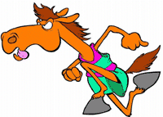THE HORSE AND THE COW 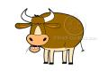

On your mark, get set, go!

Every year in September there are many different kinds of animal races. Lucky the Horse and Jack the Cow are always the winner in their class. Lucky bragged, “I can out run any and every animal here! I am as fast as lightning!”

Lucky always made fun of the other animals, but one day, Jack had heard all of Lucky’s bragging that he could stand. Jack mooed, “I’m not scared of you, I’ll race you, and I’ll win too!”

Lucky laughed, “What a joke! Just look at my long slender body and your chunky self. Great, we have got ourselves a race! I’ll beat you before you even get started!”

Jack mumbled, “Don’t be over confidant, we will see who the winner is at the finish line.”

All the other race animals 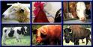 gathered up to watch the race, and they knew the Lucky was much faster than Jack and knew he would win.

Squeak, the Mouse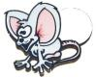 asked Jack, “What do you think you are doing? You know Lucky will win.”

Jack responded, “I know I can do it, and I’ll show you and everyone else I can.”

Squeak screeched, “On your mark, get set, go,” and the two were off. Lucky shot off like a bullet leaving Jack way behind.

Lucky looked back and saw how far ahead he was of Jack and muttered, “I am in no hurry. I think I’ll go get some new shoes.” He went off track headed to the Mast General Store.

Meanwhile, Jack stayed at a steady pace going as fast as he could.

Lucky got new shoes on all four feet, and he was so proud of them, he went around showing them off. He shouted to the other race animals, “Look at my new shoes, not everyone can get new shoes and win a race at the same time!”

Squeak warned, “I’m not so sure you are going to win the race.”

Lucky interrupted, “What do you mean you are not sure I’m going to win the race? Of course I’m going to win. I am just giving Jack a chance to get ahead a little, so it doesn’t look so bad when I beat him!”

Sly, the Rooster 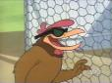 yelled, “Look, Jack has just crossed the finish line!”

Lucky couldn’t believe his eyes, when he saw that Jack had just won the race! Now Lucky is not as confident as he once was, thanks to Jack! The race animals cheered!

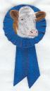Jack was awarded with a first place ribbon for his hard work and determination. Remember, do not be over confident, there is always someone who is better than you! If you give it your all, and do your best, you are already a winner!

