The Frog Princess
By E.D. Baker
~
Frog (Watch Me Grow)
By Lisa Magloff

“A girl likes to think that her very first kiss will be something special. Well, I’m not going to kiss you! I have no idea where you’ve been. I could catch some awful disease. Besides, considering what you must eat, I bet you have awful breath.”

~Princess Emeralda

“Maybe you would feel otherwise if you knew I was a prince turned into a frog by an evil witch. I had the misfortune to criticize her fashion sense. She didn’t take kindly to my comment.”
~Prince Eadric, aka “Frog”

Name: _____________________________________________________
What I Noticed About These Areas
AREA 1

AREA 2

AREA 3

K-W-L

You will be completing a K-W-L on frogs. Think about what you know, what you want to know, and finally what you have learned. Use the following words to help you come up with questions you would like answered for the “W” column.

WHO, WHAT, WHEN, WHERE, WHY, & HOW

K  What I Think I KNOW | W  What I Want To KNOW | L  What I LEARNED

After reading Frogs (Watch Me Grow) by Lisa Magloff and gaining an understanding of your topic, go back to the “K” column and see if any of the ideas you ‘”thought you knew” were inaccurate. Check any of them that are inaccurate, according to the text. Rewrite any of your statements that were inaccurate so that they are correct. Then go to the “L” column and begin grouping or categorizing what you have learned.
Before You Read: Look carefully at the front and back covers of The Frog Princess. Write down your predictions about the following:

Setting (Time and Place): When and Where do you think this book takes place?___________________________
________________________________________________

Characters (The people, animals, or objects around which the action of the story is centered): Who do you believe the main characters in the book will be?____________________
________________________________________________

Problem(s) & Solution(s) (What goes wrong in the story and how is it solved?): What do you predict will be the most significant problems in this book? How do you believe the problems may be solved? _________________________
________________________________________________
________________________________________________
Write down any other questions or predictions: ___________
________________________________________________
Book
Choose one or two items from the chart below to create pages for an alphabet book for all to share. Each page should include a large capital letter, an illustration or some artistic impression, and a paragraph (at least 5 sentences) explaining your letter representation. Design your page with an interesting format and type font. Your page should be vertical. The following words are examples you may use but are not limited to:

A  Aunt Grassina  Appearance | B  Bright Country  Books | C  Charm Bracelet  Curse  Castle | D  Dragon’s breath  Dogs | E  Emeralda  Enchanted
F  Fairytale  Fang | G  Green Witch  Great Hall | H  Haywood | I  Impersonation | J  Jorge
K  Kiss | L  Li’l Stinker  Laugh | M  Mudine  Marriage  Magic | N  Nymph | O  Otter
P  Prince Eadric  Princess  Predator  Parchment | Q  Queen Chartreuse  Quagmire | R  Royal Highness | S  Swamp  Spell | T  Tongues & Toes  Talisman  Transformation
U  Undo  Unhappy | V  Vannebe  Vial | W  Witch  Whoosh! | X  eXpectations | Y  Yuck!  Z  Zigzag

Character Sketcher

Your job as Character Sketcher is to identify a character’s actions (traits) and explain or prove these traits., identify the character’s goal (which is what the character wants to do or accomplish), identify the problem and solution in the reading, and complete a sketch or illustration of the character.

You need to be aware that the character traits you will choose will be implied character traits. In other words, they are not directly stated in the passage. You really want to use descriptive words for your character traits. You do NOT want to use words like good, bad, nice, and mean. Be sure to use your “Descriptive Character Traits” page for help.

Sometimes the solution to your character’s problem will not be in the section of the book that you are reading. In this case, you will need to come up with a possible solution for you character’s problem. When you begin artistically representing your character, try to use any physical descriptions from the text to help you. Your “artistic impression” of the character will probably be on a separate piece of paper. The next page gives you an example of how your paper may look with the character information.

Character’s Name_______________________

Section and title of book you are reading: ______________________

Implied Character Traits (3)

- (trait) _________________ p.______ par.________
(explanation or proof of trait)

_____________________________________________________________________

_____________________________________________________________________

- (trait) __________________p.______par._________
(explanation or proof of trait)
___________________________________________________
___________________________________________________

- (trait) __________________p.______par._________
(explanation or proof of trait)
___________________________________________________
___________________________________________________

Character’s Goal:
_______________’s goal is to
___________________________________________________.
Problem:
_______________’s problem is
___________________________________________________.

Solution or Possible Solution:_____________________________
___________________________________________________.
V o c a b u l a r y


You will complete the following chart with child-friendly definitions for these words. Then, you are invited to complete a set of daily vocabulary activities to go with these words.

Word | Meaning
churlish
p. 4

diminutive
p. 13

unencumbered
p. 32

copse
p. 60

apparition
p. 65

discreet
p. 66

Vocabulary Activities (Week 1)

Sentence Stems/Idea Completions
- The old man was a churlish person because ______________
_________________________________________________.
- A bank robber must be discreet because ________________
_________________________________________________.

Questions, Reasons, Examples
- If you were lost in the woods and needed to find a place to sleep, where might you spend the night?
- If you were to something you knew couldn’t possibly be there, you might have seen what?

Making Choices
- Which of the following could be described as “diminutive?” Circle your answers:
1. an elephant
2. a shoe
3. a mouse
4. a house
5. the United States of America

Examples and Non-examples
Which would best illustrate the word unencumbered?
- A homeless man or a student with a book bag?
- An obstacle course or a straight pathway?
Word Networks
- What people, things, situations, or words come to mind when you think about the word apparition?

Apparition

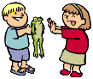 Discussion Director:
The Frog Princess

- Your job is to involve the students in your group by thinking and talking about the selection of the book you have just read. You are going to ask questions that really help the students in your group think about the reading. Your questions should require students to discuss their interpretations of the text and connect background experience and knowledge with the text. You want all students involved in the discussion and talking about the issues that come up during the reading.

- Your job as the Discussion Director is to come up with 5 thinking questions. Your teacher really wants you to help the students in your group to go back to the book to find their answers if they don’t know them. So, to help this run very smoothly, you need to write down the questions, and the page numbers where the students can reference the text to justify their responses to your questions.

- When developing your questions, think about Princess Emeralda’s experiences in the castle, conversations with her mother-- Queen Chartreuse, her adventures in the swamp, her first day as a frog, how she met “Frog” (aka Prince Eadric), how Emeralda feels now that she’s not human anymore, what she must do to survive, how she thinks she might be able to reverse the spell, etc.

- Remember to ask BIG, FAT, JUICY THINKING QUESTIONS!! No skinny questions allowed!

Double-Entry Diary
You are invited to complete a Double-Entry Diary for this section of the book. Remember to write down the quotation or passage and the page number on the left side of your paper. On the right side of your paper, write your response or personal reactions and connections to what was written in the left column.

Here’s an example to start with:

Quotation/Passage and page number | Your response, reactions, and connections to the quotation or passage
“I couldn’t imagine what blinking had to do with the fly in my mouth, but I tried it anyway. I blinked. When my eyelids closed, my eyeballs pushed down on my throat, and I swallowed the fly. I shuddered when I realized what I’d done.”  Pg. 43, | When I read this, I immediately thought of a time when I was riding my bike when I was little. I accidentally swallowed a fly because I had my mouth open too much. It was extremely gross. I wanted to gag.  This passage makes me want to learn more about frogs. I wonder if their eyeballs really push food down their throats. It sounded really cool and I want to learn more about it !

Double Entry Diary
- Now YOU try it!
Quotation/Passage and page number | Your response, reactions, and connections to the quotation or passage
Retrieved from: www.vickiesnovelties.com
Author’s Craft

E.D. Baker chooses her words very carefully, making use of several interesting literary devices. She appeals to the reader’s senses and sense of humor by using figurative language. Find two examples of each listed below. Then explain how each passage adds meaning to the story.

 | Page Number/  Example/  What does this passage add to the story? | Page Number/  Example/  What does this passage add to the story?
Onomatopoeia: a word(s) that imitates the sound it represents

Page 30: Thump! Thump! Thump! Something large and wet pressed against my back, snuffling hot, smelly air from my head to my feet.
Simile: a comparison that includes the words like or as

Page 58: A strange look came over the dog’s face and it dropped the toad as if it were hot.

Artistic Representation

Now that you have chosen two examples of similes, please artistically represent one of these comparisons. You may use any artistic medium. The following are options: colored pencils, watercolors, pastels, collage, etc. Enjoy!

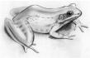
Retrieved from: www.seagrant.wisc.edu

V o c a b u l a r y

You will complete the following chart with child-friendly definitions for these words. Then, you are invited to complete a set of daily vocabulary activities to go with these words.

Word | Meaning
Inconvenience
p. 77

Indignant
p. 84

Conspicuous
p. 108

Immensity
p. 113

Endeavor
p. 147

Vocabulary Activities (Week 2)

Sentence Stems/Idea Completions
- Being stuck in traffic is an inconvenience because_________
_________________________________________________.
- The Queen was indignant because she thought ___________
_________________________________________________.

Questions, Reasons, Examples
- If you were trying not to be conspicuous, you might NOT wear what?

Making Choices
- Which of the following could be described as an “endeavor?” Circle your answers:
1. building a bridge
2. swimming
3. becoming President of the United States
4. going skydiving
5. tying your shoelaces

Examples and Non-examples
Which would best illustrate the word immensity?
- Having a heavy burden to carry or being carefree?
- An idea that means something or a spur-of-the-moment idea?

Create a Word Network for “nymph”
Writing a Feature Story

EXTRA! EXTRA! READ ALL ABOUT IT! You are invited to write a feature story (using Microsoft Publisher) dispatching the tale of the missing princess. Recount the story from her mother’s point of view, or Prince Jorge, or Aunt Grassina. Pretend you are a news reporter writing the thrilling story, or in their words, tell what they think might have happened to their Emeralda. Another option is that you can recount Princess Emeralda’s harrowing adventure from the day she got “lost” to the day she was found. You will need to do the following:

- Think of a name for your newspaper—“The Once Upon a Time Times.”
  - For common newspaper names see the following: http://en.wikipedia.org/wiki/List_of_common_newspaper_names

- Write an interesting title for your feature story—“Princess Emeralda Missing and the Frogs Are the Only Ones Talking!”
- Describe Emeralda’s adventure or another character’s point of view.
- Be creative!!!

When writing a feature story remember:
- The main purposes of a feature story are to set the tone and grab the reader’s attention--to draw the reader in—to make him or her curious.
- A chronological or narrative pattern of organization is used.
- The final paragraph should complete the story.
- The best ways to do this are to refer back to the lead or use a quote to refer to the future.
- The story should reflect the subject’s character and personality.
- Feature stories should contain direct quotes.
- Write creatively, use color and imagination, and cause people to come ALIVE with your writing.

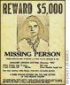Retrieved from: www.crimelibrary.com
Create A Missing Poster for one of the following characters:

- Princess Emeralda
- Prince Eadric
- Haywood
- Mudine, the witch
- Any other MAIN character who is “missing”

You will complete an artistic representation of the character and then complete the following information for your character:

MISSING:
Character name
Time and Place Last Seen
Physical Description
Acts
Likes
Dislikes
Hang Outs
Suspected Whereabouts

**Please make this as creative as possible!!!
Internet Workshop for The Frog Princess

This internet workshop will introduce you to frogs. You will have an opportunity to explore information on the Internet. Take notes in your Internet Journal. Come prepared to share your information at our workshop session. We will discuss possible ways of presenting your information (Inspirations, PowerPoint, Poster, Graphic Organizer, What Am I Poem, Who Am I Poem, or I Poem). http://www.graphic.org/index.html

Please complete the following workshop. See rubric for presentation information:

Read about “What Is A Frog?” and then click on
http://www.abc.net.au/schoolstv/animals/FROGS.htm Scroll down to “Frogs are carnivores” to read about how and what frogs eat to survive. Do you think all animals eat this way? Why or why not? Please be prepared to justify your responses. Next, you will click on the following site to learn about the life cycle of frogs.

http://www.seagrant.wisc.edu/frogs/cool_science.html Click on “Explore a Frog’s Life Cycle.” Go through each step, clicking “Next” at the bottom of each page until you reach the end.

Please answer the following questions:

What does the word “amphibian” mean? Why are frogs called “amphibians”?

What bodily changes does the frog or tadpole undergo? How? (Be sure to look at the pictures.)

Do frogs live on land or in water? Explain your reasoning. Report your findings back to your group.
Learning Log/Response Journal

Throughout the book, Princess Emeralda is constantly attacked by predators (animals that eat other animals). She is on the run from a dog that tries to eat her. Then, after escaping from Vannebe’s cottage with the other imprisoned critters, she is nearly eaten by an owl that swoops down to grab her with his sharp claws. Luckily, Fang rescues her from harm.
Imagine yourself in Emeralda’s place. How do you think you would feel if you went from being high on the food chain to being at the very bottom? Has there ever been a time when you felt scared, in danger, or alone? Explain.

Reader’s Theatre

- E.D. Baker reveals the characters in The Frog Princess by how they speak, what they do, and by how they look. She uses Princess Emeralda’s first-person narration and dialogue so that readers may “hear” the characters’ voices. You are invited to prepare a Reader’s Theatre presentation for a scene from the book. The scene should be no less that 2 pages and no longer than 8 pages. Read Readers on Stage: A Guide to Reader’s Theater (or Reader’s Theatre) by Aaron Shepard to help you with the process. Http://www.aaronshep.com/rt/Tips.html

- In one form of Reader’s Theatre, students are assigned to read both narration and the dialogue in certain sections of a book. A narrator(s) reads the non-dialogue parts. If the non-dialogue parts become long, or are more than one paragraph at a time, there is often more than one narrator. The students sit on stools or chairs in the front of the classroom. No scenery or props are necessary.

- Use the book to write your script! Remember to be creative with your voice, facial expressions, and movements as you read through the scene. It’s important to make the audience believe you ARE the character from whose voice you are speaking!!!

Poem for Two Voices

Select two main characters from the book The Frog Princess and compose a poem for two voices. Think of something that the characters might have different views about. Then, get them to talk to one another. Use the poem by Paul Fleischman or Allan Wolf as a model for your writing. To read Fleischman’s and Wolf’s poems, you need two voices. Lines written across from one another are read together. Although these poems rhyme, yours doesn’t have to. In addition, you are invited to include an artistic representation that symbolizes a theme in your poem.

You may want to write your poem with a partner. You might also want to write a poem for three or even four voices.

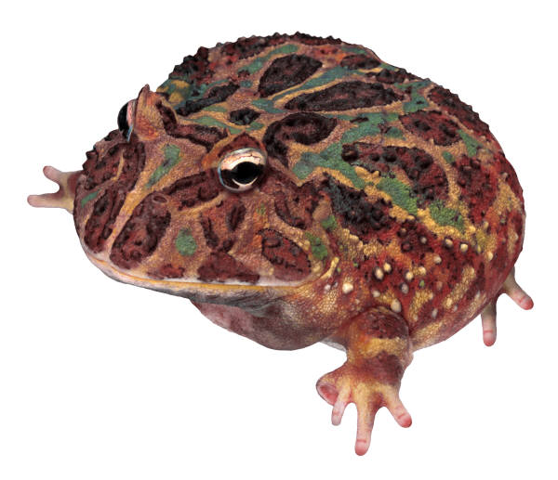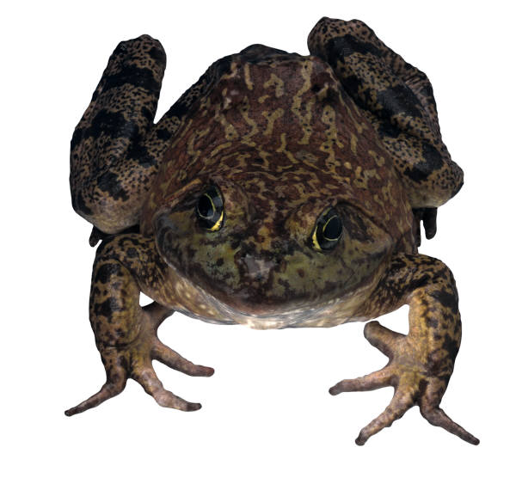
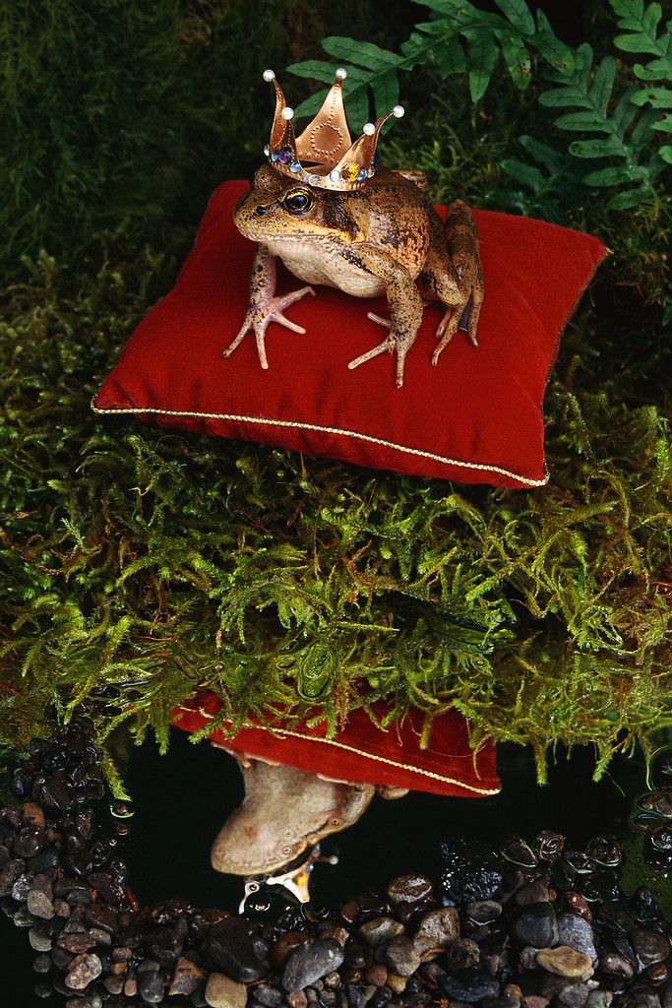
“I Poem”
Write an I Poem from the point of view of a main character in The Frog Princess. Try to get inside your character; help the reader identify with the character’s thoughts, actions, emotions, and personality. If possible, include personification and similes in your poem. You may wish to use the format presented below. Or, you may want to use your own format.
FIRST STANZA
I am (two special characteristics you have)
I wonder (something you are actually curious about)
I hear (an imaginary sound)
I see (an imaginary sight)
I want (an actual desire)
I am (the first line of the poem repeated)
SECOND STANZA
I pretend (something you actually pretend to do)
I feel (a feeling about something imaginary)
I touch (an imaginary touch)
I worry (something that really bothers you)
I cry (something that makes you very sad)
I am (the first line of the poem repeated)
THIRD STANZA
I understand (something you know is true)
I say (something you believe in)
I dream (something you actually dream about)
I try (something you really make an effort to do)
I hope (something you actually hope for)
I am (the first line of the poem repeated)

Final Vocabulary Assessment
Multiple Choice
Underline the best response or responses:
- If you were a churlish person, you might be:
  - A cranky old lady
  - A sweet schoolgirl
  - A soccer mom
- If you a diminutive animal, you might be a:
- Horse
- Mouse
- Elephant
- An example of a person who is unencumbered might be:
  - A student who just got out of school for the summer
  - A businessman with a ton of paperwork
  - A friend who likes rap music
- Where might you stumble upon a copse?
- In the desert
- On a boat in the middle of the ocean
- In the woods
- What is the best example of an apparition?
  - An old man who just recently died
  - A ghost
  - An recently discovered picture of your old dog
- A person who is discreet when walking in late to a meeting might:
  - Talk loudly to the person next to him/her
  - Sit down quietly without bothering anyone
  - Walk right in front of the speaker and obstruct everyone’s view
- An inconvenience might best be described as:
  - Having someone pay for your lunch one day
  - Opening a can of soup
  - Having to go back to the grocery store because you forgot to buy milk
- A person who is indignant could best be described as:
  - Angry
  - Hopeful
  - Tired and restless
- A person who is conspicuous might:
  - Stick out like a sore thumb
  - Blend right in
  - Walk alone at night
- An object described as having immensity is:
  - Huge or enormous
  - Small or tiny
  - Closed in
- A nymph might be described as:
  - Ugly
  - Beautiful, small, and fairy-like
  - Bigger than an oak tree
- A person who undertakes a great endeavor might:
  - Be lazy
  - Have no brains or wits
  - Work hard to get where he/she wants to be

Rubric
Activity/Criteria  NOTE: This packet is to be word-processed! | Your points/Total possible points
Pre-Reading Activities  - Examples are complete; thought and effort is demonstrated  - K-W-L is complete  - Predictions of Story Elements complete | /5
Page for ABC Book  - Information is correct and interesting  - Information is organized  - Design is creative, colorful, and inviting | /5
Character Sketcher  - Sketch includes thoughtfully selected information about the character, including 3 implied character traits, problem and solution, and character goal  - Artistic Impression is creative and demonstrates knowledge of information given in text regarding character’s physical description | /5
Discussion Director  - Questions displays insight into novel’s main events and themes; questions are “higher-level”  - Answers are provided and when appropriate, page #’s | /5
Vocabulary Definitions and Activities  - Definitions are “child-friendly” and correct  - Activities are correct and complete | /5
Double-Entry Diary  - Example is well chosen, well explained and thoughtfully crafted  - Provides more than one thoughtful idea/supporting reason | /5
Internet Workshop (1 workshop complete)  - Notes reveal thoughtful preparation for participation;  - Information in graphic organizer, PowerPoint or poem is correct and well organized; main ideas are present.  - Visual representation is present. | /10
Author’s Craft  - Chart includes 2 well-chosen examples of simile and onomatopoeia from the novel  - Explanations are included of how figurative language adds meaning to the text  - Artistic representation is thoughtful and creative | /5
“I Poem”  - Is in the form of an I poem  - Includes thoughtfully chosen words and images to reveal character  - Includes alliteration, simile or metaphor | /5
Learning Log/Response Journal  - Log/journal is complete  - Includes thoughtful comments and connections to text  - Includes connection to personal life  - Answers question | /5
Feature Story  - Interesting lead grabs the reader  - Concise, organized, and creative story which includes necessary details and reveals understanding of main character’s personality  - Specific examples in text are referenced  - Word choice is thoughtful and demonstrates an understanding of the historic nature of the events as well as free from grammar and spelling errors | /10

Poem for Two Voices  - Poem reveals insight into characters selected  - Poem includes dialogue that is true to the characters  - Artistic representation is creative and thoughtful  Reader’s Theatre  - Script is carefully planned and well-organized  - Dialogue and narration are present  - Performance rubric:  - Intonation  - Clarity  - Expression  - Fluency  Missing Poster  - Biographical information is present  - Includes thoughtfully chosen words and images to reveal character  - Information is presented creatively (not just listed)  - Artistic representation is creative and thoughtful  Total | /5
 | /10
 | /5
 | /85

